AGENDA

Thursday, August 6, 2026
6:00 p.m.

City Council Candidate Orientation
Evans Community Complex
1100 37th Street
Evans, CO 80620

DO HEREBY CALL AND GIVE PUBLIC NOTICE of a Mail Ballot Municipal Election in the City to be held on Tuesday, the 3rd day of November, 2026 (herein the “Election”). Nomination Petition packets can be picked up and distributed for signatures beginning on August 4, 2026. Nomination Petitions must be returned no later that 5:00 p.m. on August 24, 2026.

The City is holding an informational orientation on Thursday, August 6, 2026 at 6:00 p.m. at the Evans Community Complex located at 1100 37th Street, Evans. Please contact Julie Barnett, City Clerk at 970-475-1104 or jbarnett@evanscolorado.gov for more information.

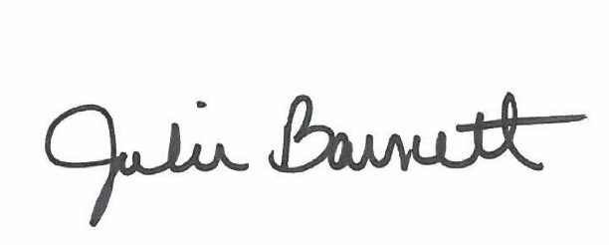
Persons desiring to vote in said Election must be registered to vote at their current address located in the City of Evans, Colorado and must meet the following qualifications: be at least eighteen (18) years of age, a citizen of the United States, a resident of the State of Colorado, and a resident of their municipal precinct or “Ward” for at least thirty (30) days before the Election.

______________________________________
Julie Barnett, City Clerk
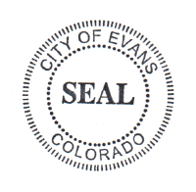
Posted: July 27, 2026

