PUBLIC NOTICE

SPECIAL WORK SESSION AND STRATEGIC RETREAT

Please take notice that members of the Evans City Council will be attending a Special Work Session Strategic Retreat on Saturday, October 4, 2025 beginning at 9:00 a.m. in the Cottonwood Room at the Evans Community Complex, 1100 37th Street, Evans, CO 80620.

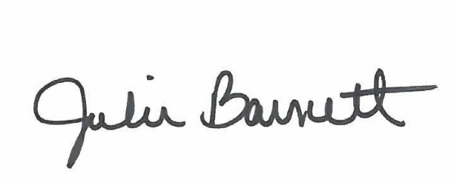

______________________________________
Julie Barnett, City Clerk

Posted: September 25, 2025

