PUBLIC NOTICE

Please take notice that members of the Evans City Council will be attending the Chief of Police Candidate meet and greet event on Wednesday, June 4, 2025 beginning at 5:00 p.m. in the Council Chambers at the Evans Community Complex, 1100 37th Street, Evans, CO 80620.

At least three members of the City Council expressed interest in attending this meeting.
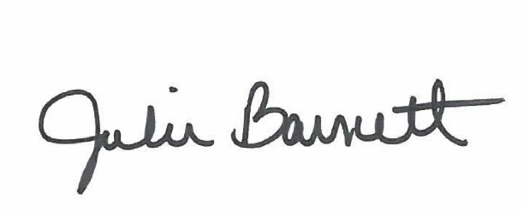

______________________________________
Julie Barnett, City Clerk
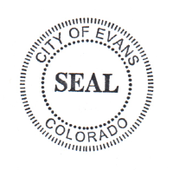
Posted: June 2, 2025

